**Goal:** Create custom Parsley process that builds pumper, foreman, and basin cost allocation groups based on property attributes.

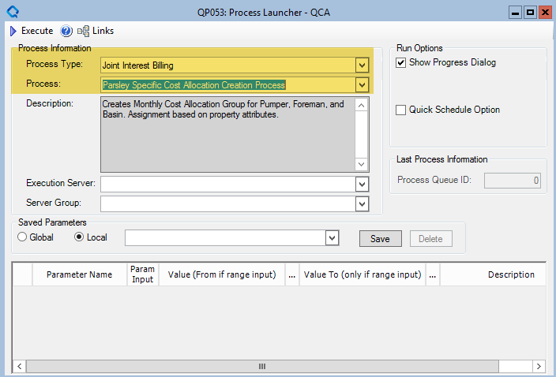

*\*No parameters will need to be inputted by the user to launch this process*

**Steps Need in Maintenance App**

1. Create process step “PARCOSTGRP” that will call stored procedure “PAR_SP_CREATE_ALLOC_GRP.”

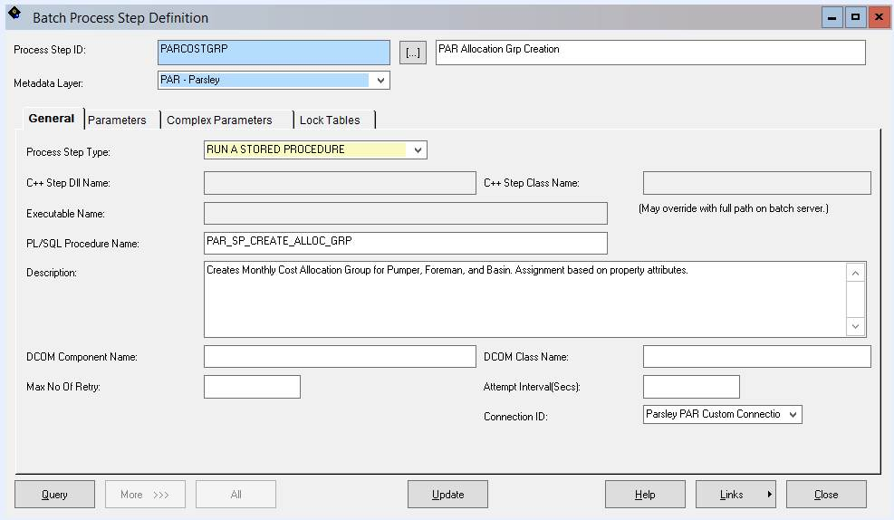

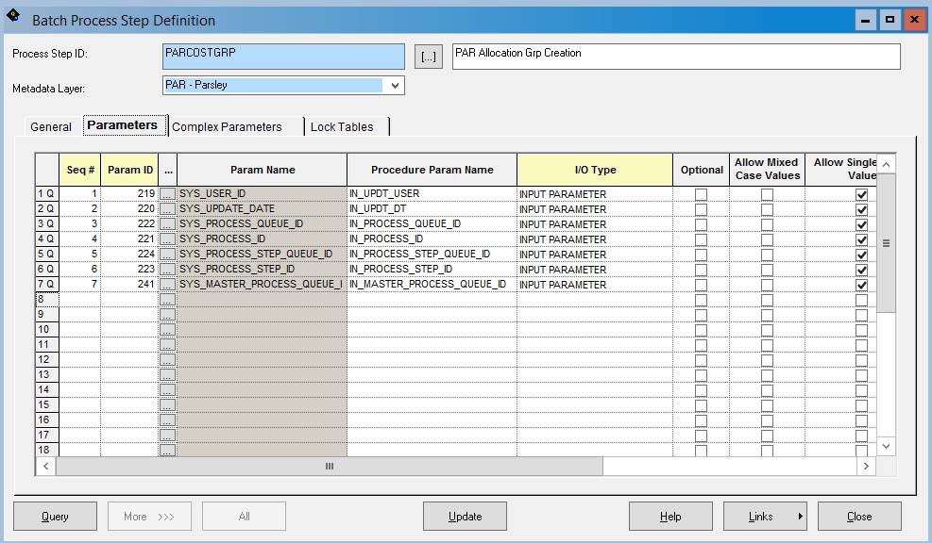

1. Create Main Process “PARCOSTGRP”

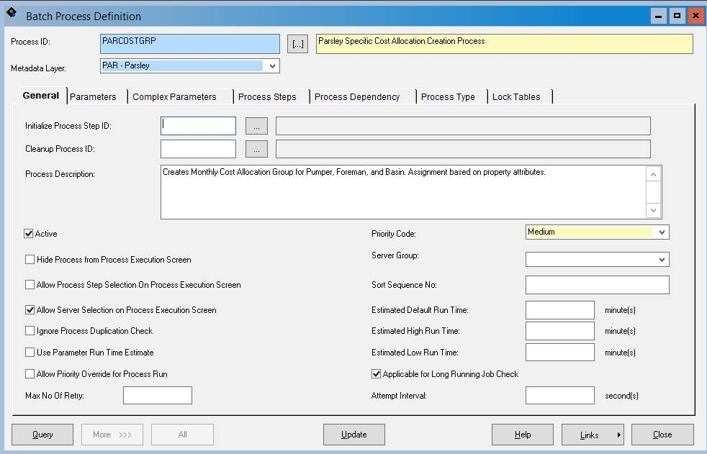

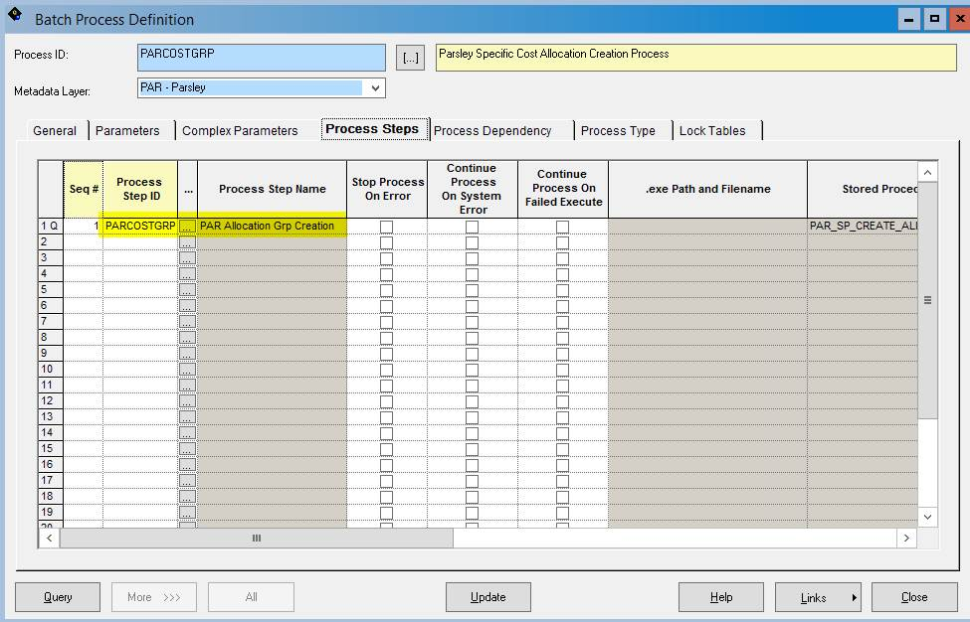

1. Add new process to “Joint Interest Billing” process type.

